CNHS Bus Dismissal 2020-2021
Hi Folks,
Here is a map of our bus locations in the afternoons. I’ve included a general idea of where buses are headed. I hope this is a help to teachers and students as we kick off the school year.
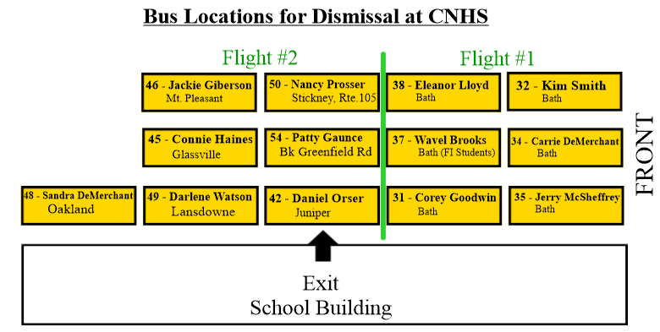

Buses will still arrive and line up in front of the school as they have in the past.

Flight #1: Front 6 buses in the lineup will dismiss at 3:08 pm (32, 34, 35, 38, 37, 31)
Flight #2: Back 7 buses in the lineup will dismiss at 3:12 pm (50, 54, 42, 46, 45, 49, 48)
Flight #3: These buses drive around behind the school and wait at the side of the school for Flight #1 and 2 buses to depart, then load directly in front of the bus doors in the order in which they arrive – one at a time. This order doesn’t matter.
This includes the following buses:
51 - Rob Stephenson – Florenceville area 47 - Mary White – Bristol area
52 – Rachael Williams – Burnham Rd / Oakland 43 – Nancy Guthrie – West Glassville, 107
64 – Sarah Nicholson – Lakeville / Centreville 40 – Gailen Allen - Glassville
58 – Veronica Williams – Centreville / Wicklow (transfer) 62 – Gordie Phippen – Centreville / Royalton

** Also, please note that no morning buses are allowed to drop off students before the school opens at 8:00 a.m. and
a teacher is on duty. Many thanks. **

CNHS A.M. Buses:
31 – Corey Goodwin
40 – Gailen Allen
42 – Daniel Orser
43 – Nancy Guthrie
45 – Connie Haines
46 – Jackie Giberson
47 – Mary White
51 – Rob Stephenson
54 – Patty Gaunce
59 – Greg Tompkins
62 – Gordie Phippen

